**Information System Management Lab**

**BCOM 307**

**Assignment #23**

***Submitted by:***

**Name:** YASH JAIN

**Enrollment No:** 03914788818

**Semester:** B.Com(H) 5th Semester

**Class:** B.COM(H)

**Section:** B.Com 5A

**Date of Submission:** 29/10/2021

***Submitted to:***

**Praveen Kumar Singh**

**Assistant Professor, MAIMS**



**Department of Commerce**

**Maharaja Agrasen Institute of Management Studies**

**Affiliated to Guru Gobind Singh Indraprastha University, Delhi**

**Sector -22, Rohini, Delhi -110086, India; www.maims.ac.in**

Maharaja Agrasen Institute of Management Studies

Affiliated to GGS IP University; Recognized u/s 2(f) of UGC Recognized by Bar Council ofIndia; ISO 9001: 2015

Certified Institution Sector 22, Rohini, Delhi -110086, India; [www.maims.ac.in](http://www.maims.ac.in/)

Department of Commerce

Academic Year: 2020-21

Semester: Vth

# Assignment No. 23

# Unit No:

**Course/Subject Code:** BCOM 307 **Subject Title: Information System Management Lab**

# Issue Date Last Date of Submission:

**Instructions for Students:**

# All Questions are Compulsory.

1. The student should attach proper cover page for each assignment clearly mentioning the Assignment No.
2. Each assignment should be prepared by the student individually with proper explaination and screenshots.
3. A4 size ruled sheets should be used for the assignment.
4. Assignment pages should be serially numbered at the bottom of page.

***During online education mode, upload scanned copy of the complete assignment including cover page latest by due date.***

|  |  |  |
| --- | --- | --- |
| **Question No.** | **Question** | **CO No.** |
| 1 | Calculate average salary of each department. | **CO2, CO3, CO4, CO5** |
| 2 | Find out the department id where the number of employees is more than 2. |
| 3 | Display the distinct location from employee table in descending order. |
| 4 | Update the salary of all employees whose location is Delhi by 20%. |
| 5 | Display the employee name whose commission is more than the average commission. |

**ASSIGNMENT 23 - SQL INNER JOIN CLAUSE II**

**Task 1 : Calculate average salary of each department.**

This task can be completed using the **SQL INNER JOIN Clause** used with the **GROUP BY** Clause.

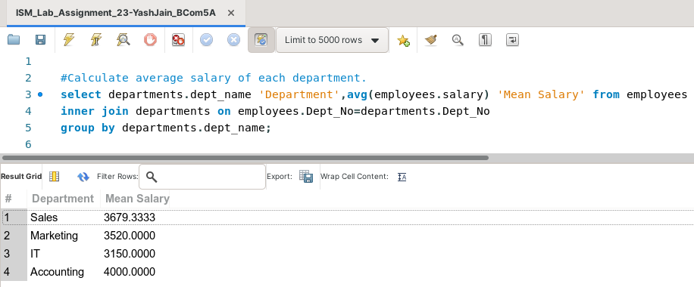

**Task 2: Find out the department id where the number of employees is more than 2.**

This task can be completed using the **COUNT( ) Aggregate function, GROUP BY** and **HAVING** clause.

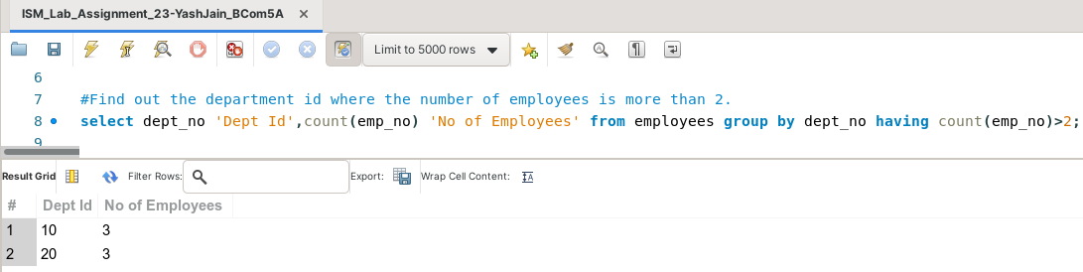

**Task 3: Display the distinct location from employee table in descending order.**

This task can be completed using the **DISTINCT** and the **ORDER BY** clause.

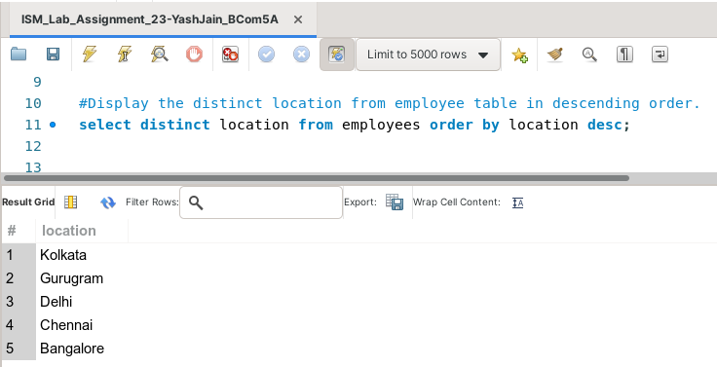

**Task 4: Update the salary of all employees whose location is Delhi by 20%.**

This task can be completed using the **UPDATE** Command and the **SET** Keyword.

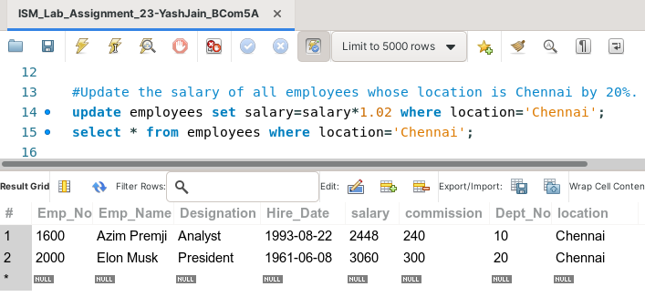

**Task 5: Display the employee name whose commission is more than the average commission.**

This task can be completed using the **AVG( ) Aggregate Function** in the **SQL Sub-Query** along with the **SELECT** statement.

